
Artificial Intelligent
LAB - 5

Robotics Scenarios and Simulations in Python
Scenario 1: Simple 2D Robot Motion
Problem
Simulate a robot that moves in a 2D plane in a straight line with constant speed and direction.
Robot's Solution
The robot uses simple kinematic equations to move based on its orientation (theta) and speed.
Code & Logic
x, y = 0, 0 Start position
theta = np.pi / 4 Angle: 45 degrees
v = 1 Constant speed
Time steps
for t in time:
x += v * np.cos(theta) * 0.1
y += v * np.sin(theta) * 0.1
- cos(theta) and sin(theta) determine direction.
- Position updated every small time increment (0.1).
- The path is plotted using matplotlib.
Code:
import numpy as np
import matplotlib.pyplot as plt

x, y = 0, 0
theta = np.pi / 4 # 45 degrees
v = 1 # velocity
time = np.linspace(0, 10, 100)

x_path, y_path = [], []

for t in time:
x += v * np.cos(theta) * 0.1
y += v * np.sin(theta) * 0.1
x_path.append(x)
y_path.append(y)

plt.plot(x_path, y_path, label='Robot Path')
plt.title('Simple 2D Robot Motion')
plt.xlabel('X')
plt.ylabel('Y')
plt.legend()
plt.grid(True)
plt.axis('equal')
plt.show()
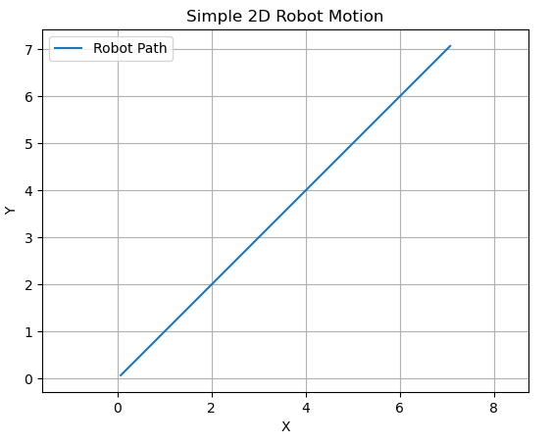

Scenario 2: Obstacle Avoidance
Problem
A robot moves in a grid and must avoid static obstacles by changing direction.
Robot's Solution
If an obstacle is detected in the next cell, the robot turns 90 degrees clockwise.
Code & Logic
directions = [(1, 0), (0, 1), (-1, 0), (0, -1)] # Right, Up, Left, Down
for _ in range(15):
next_x = x[-1] + directions[dir_index][0]
next_y = y[-1] + directions[dir_index][1]
if (next_x, next_y) in obstacles:
dir_index = (dir_index + 1) % 4 # Turn right
continue
- Maintains direction index.
- Checks next position for obstacles.
- If blocked, rotates right.
Code:
import matplotlib.pyplot as plt

x, y = [0], [0]
directions = [(1, 0), (0, 1), (-1, 0), (0, -1)] # Right, Up, Left, Down
dir_index = 0
obstacles = {(3, 0), (4, 0), (0, 5)}

for _ in range(15):
next_x = x[-1] + directions[dir_index][0]
next_y = y[-1] + directions[dir_index][1]

if (next_x, next_y) in obstacles:
dir_index = (dir_index + 1) % 4 # Turn right
continue
x.append(next_x)
y.append(next_y)

for ox, oy in obstacles:
plt.plot(ox, oy, 'rs') # obstacle

plt.plot(x, y, 'bo-')
plt.title('Obstacle Avoidance')
plt.grid(True)
plt.axis('equal')
plt.show()
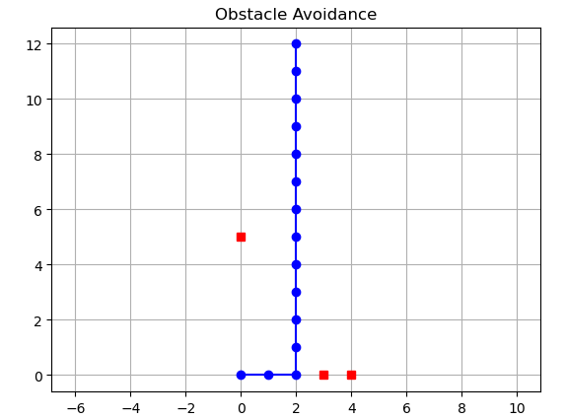

Scenario 3: Line Following using PID Controller
Problem
The robot must follow a curved line path using sensor feedback.
Robot's Solution
A PID controller adjusts the robot’s movement to reduce error between desired and actual path.
Code & Logic
error = y_desired[i] - y_robot
y_robot += Kp * error + Ki * error_sum + Kd * derivative
- Kp, Ki, Kd: PID gains.
- error: difference between current position and target.
- PID uses error, its sum (I), and rate of change (D) to update the path.
Code:
import numpy as np
import matplotlib.pyplot as plt

# Desired path
x = np.linspace(0, 50, 500)
y_desired = 8 * np.sin(0.1 * x)

# PID Controller parameters
Kp = 0.5
Ki = 0.01
Kd = 0.1

y_robot = 0
y_path = []
error_sum = 0
prev_error = 0

for i in range(len(x)):
error = y_desired[i] - y_robot
error_sum += error
derivative = error - prev_error
y_robot += Kp * error + Ki * error_sum + Kd * derivative
prev_error = error
y_path.append(y_robot)

plt.plot(x, y_desired, 'r--', label="Desired Path")
plt.plot(x, y_path, 'b-', label="Robot Path")
plt.legend()
plt.title("Line Following Robot (PID)")
plt.grid(True)
plt.show()
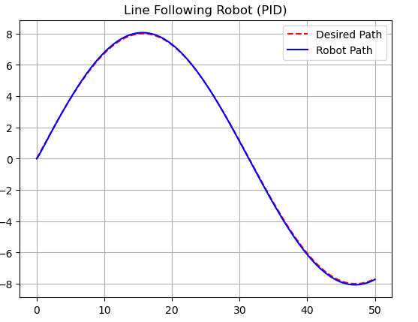

Scenario 4: Path Planning with A*

Problem
Find the shortest path from start to goal in a grid with obstacles.
Robot's Solution
Uses A* search algorithm with a heuristic to find optimal path.
Code & Logic

heapq.heappush(open_list, (f, cost, current, path))
- f = cost + heuristic.
- Heuristic: Manhattan distance.
- Maintains open list as a priority queue using heapq.
Code:
import heapq

grid = [[0, 0, 0, 1, 0],
[1, 1, 0, 1, 0],
[0, 0, 0, 0, 0],
[0, 1, 1, 1, 1],
[0, 0, 0, 0, 0]]

start = (0, 0)
goal = (4, 4)

def heuristic(a, b):
return abs(a[0] - b[0]) + abs(a[1] - b[1])

def a_star(grid, start, goal):
open_list = []
heapq.heappush(open_list, (0 + heuristic(start, goal), 0, start, []))
visited = set()

while open_list:
_, cost, current, path = heapq.heappop(open_list)
if current in visited:
continue
visited.add(current)
path = path + [current]

if current == goal:
return path

for dx, dy in [(0,1), (1,0), (-1,0), (0,-1)]:
nx, ny = current[0] + dx, current[1] + dy
if 0 <= nx < len(grid) and 0 <= ny < len(grid[0]):
if grid[nx][ny] == 0:
heapq.heappush(open_list, (
cost + 1 + heuristic((nx, ny), goal),
cost + 1, (nx, ny), path))
return []

path = a_star(grid, start, goal)

for i in range(len(grid)):
for j in range(len(grid[0])):
if (i, j) == start:
print("S", end=" ")
elif (i, j) == goal:
print("G", end=" ")
elif (i, j) in path:
print("*", end=" ")
elif grid[i][j] == 1:
print("#", end=" ")
else:
print(".", end=" ")
print()
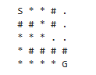

Scenario 5: Two Robots Avoiding Collision

Problem
Two robots moving toward each other in shared space must avoid collision.
Robot's Solution
Each robot monitors the other's position. If they get close, both stop.
Code & Logic
if abs(r1[0] - r2[0]) <= 1 and abs(r1[1] - r2[1]) <= 1:
dx1 = dy1 = dx2 = dy2 = 0
- Both robots use simple logic to approach each other.
- If their positions are close, movement stops.

Code:
import matplotlib.pyplot as plt

robot1 = [[0, 0]]
robot2 = [[10, 10]]

for _ in range(20):
r1 = robot1[-1]
r2 = robot2[-1]

# Simple rule: move towards each other
dx1 = 1 if r1[0] < r2[0] else -1
dy1 = 1 if r1[1] < r2[1] else -1

dx2 = -dx1
dy2 = -dy1

# Collision avoidance
if abs(r1[0] - r2[0]) <= 1 and abs(r1[1] - r2[1]) <= 1:
dx1 = dy1 = dx2 = dy2 = 0

robot1.append([r1[0] + dx1, r1[1] + dy1])
robot2.append([r2[0] + dx2, r2[1] + dy2])

robot1 = list(zip(*robot1))
robot2 = list(zip(*robot2))

plt.plot(*robot1, 'r-o', label='Robot 1')
plt.plot(*robot2, 'b-o', label='Robot 2')
plt.title('Two Robots Avoiding Collision')
plt.legend()
plt.grid(True)
plt.axis('equal')
plt.show()
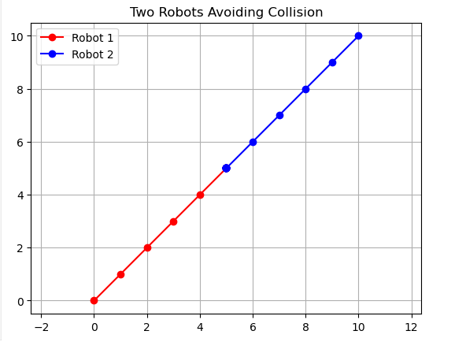

Scenario 6: 2-Link Planar Arm
Problem
Simulate forward kinematics of a 2-link robot arm.
Robot's Solution
Uses trigonometric equations to compute end-effector position.
Code & Logic
x_elbow = l1 * np.cos(t1)
x_tip = x_elbow + l2 * np.cos(t1 + t2)
- Calculates elbow and tip position.
- Plots the trajectory of the tip (end-effector path).
Code:
import numpy as np
import matplotlib.pyplot as plt

l1, l2 = 5, 3
theta1_range = np.linspace(0, np.pi, 100)
theta2_range = np.linspace(0, np.pi/2, 100)

x1, y1 = [], []
x2, y2 = [], []

for t1, t2 in zip(theta1_range, theta2_range):
x_elbow = l1 * np.cos(t1)
y_elbow = l1 * np.sin(t1)
x_tip = x_elbow + l2 * np.cos(t1 + t2)
y_tip = y_elbow + l2 * np.sin(t1 + t2)

x1.append(x_elbow)
y1.append(y_elbow)
x2.append(x_tip)
y2.append(y_tip)

plt.plot(x2, y2, 'b-', label='End Effector Path')
plt.title('2-Link Robot Arm Motion')
plt.xlabel('X')
plt.ylabel('Y')
plt.legend()
plt.grid(True)
plt.axis('equal')
plt.show()

🔹 Scenario 9: SLAM Grid Mapping (Static)
✅ Problem
Simulate robot mapping its environment as it moves.
✅ Robot's Solution
Robot uses simulated scanning in four directions and updates occupancy grid.
✅ Code & Logic
if grid[scan_x][scan_y] == 1:
grid[scan_x][scan_y] = 2 # mark as seen obstacle
- grid=1: obstacle
- grid=2: observed obstacle by sensor
- Robot moves and performs 4-direction scan.

🔹 Scenario 10: Wall Avoidance via Reinforcement Learning (Q-Learning)
✅ Problem
Robot learns to avoid hitting walls using Q-learning.
✅ Robot's Solution
Learns action values (Q-values) based on rewards and updates its knowledge over episodes.
✅ Code & Logic
q_table[pos[0], pos[1], action] += alpha * (reward + gamma * best_next - q_table[pos[0], pos[1], action])
- Actions: up, down, left, right.
- Q-table stores expected rewards.
- Robot gets negative rewards for walls and learns best routes.

Would you like me to format all these into a PDF Lab Manual or package them as a Python project folder with .py files and documentation?

